FOR IMMEDIATE RELEASE:
Press contact: Don Mitchell
dm@twofinecrowsbooks.com
808.756.5237

AWARD-WINNING POET PUBLISHES BOOK OF CHANNELS
Ruth Thompson channels conversations with other life in first nonfiction book

ITHACA, NY – When poet Ruth Thompson decided to learn to channel in 2018, she wanted to deepen the intuitive connections with nature that inspired her poetry. The skeptical product of a scientific family, she did not expect to encounter such a multitude of voices, from trees and animals to faeries, dragons, and a host of other nonphysical beings. QUICKWATER ORACLES, Thompson's delightful record of their channeled conversations – expansive, uninhibited, sometimes hilarious – will be published by Two Fine Crows Books in October, 2021.

Conscious channeling involves intentionally connecting and communicating with nonphysical fields of consciousness. Thompson's poetic gifts make her translations of these energy communications so vivid that for the reader it is almost like experiencing them in person.

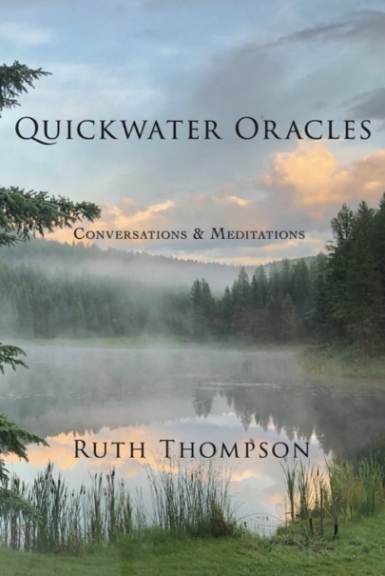
Although Thompson was in despair at the state of the world when she began to channel, these messages were filled with exuberant celebration. "Change your spectacles to joy," they told her. "To joy!" As a writer, they urged her toward deeper integrity and authenticity. And over and over, they reminded her to be in love with the world: " All is for no reason. It is for pleasure. It is for itself knowing itself!"

Inspiring but unsentimental, Quickwater Oracles is a perfect companion for daily meditation, journaling, and discussion, or can be read as one woman's channeling journey. Readers who loved Ross Gay's "The Book of Delights," Aimee
Nezhukumatathil's "World of Wonders," and Robert
MacFarlane and Jackie Morris's "Lost Spells" will treasure Ruth Thompson’s unique "joy-making and singing."

Quickwater Oracles: Conversations and Meditations
Ruth Thompson | December 4, 2021 |Two Fine Crows Books |Spirituality
Trade Paper | ISBN: 9781736525814 | Price: $20

"Do I understand channeling? No. Yet whenever I return to Quickwater I find myself happy in ways I can’t explain. Read it. You’ll never be the same."
— Mary Johnson, author of An Unquenchable Thirst

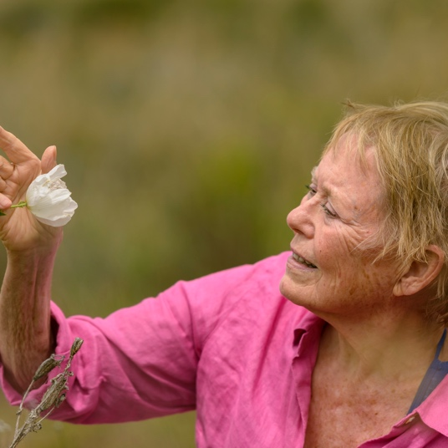
RUTH THOMPSON is an award-winning poet. QUICKWATER ORACLES is her first collection of channels. Ruth has published four books of poetry: Whale Fall & Black Sage, Crazing, Woman With Crows, and Here Along Cazenovia Creek. Her “fierce, gorgeous, sensual poems of earth-as-body and body-as-earth” have won many national awards, and have been nominated several times for the Pushcart Prize. Ruth holds a BA from Stanford University and a doctorate in English from Indiana University. She now lives near Ithaca, New York and teaches poetry, meditation, and writing from the body. Her work has been choreographed by many dancers, including Shizuno Nasu of Japan. Poems, videos, and more information here.
Ruth talks about her work here.

Press Contact: Don Mitchell
dm@twofinecrowsbooks.com

Ruth Thompson: ruth@wiasi.net
www. ruththompson.net
Instagram: @ruththompsonpoet
Facebook: RuthThompsonPoetandChannel/
Twitter: @RuthTho11588548

QUICKWATER ORACLES is available for pre-order at bookshop.org, indiebound.org, powells.com, amazon.com, barnesandnoble.com, and other vendors.

ARCs available at netgalley.com, or contact Don Mitchell, dm@twofinecrows.com

Quickwater Oracles: Conversations and Meditations
Ruth Thompson | December 4, 2021 |Two Fine Crows Books |Spirituality
Trade Paper | ISBN: 9781736525814 | Price: $20
ISBN: 9781736525814 / ebook ISBN 9781736525821
Inspirational; Spirituality; Daily Meditations

RUTH THOMPSON IS AVAILABLE FOR INTERVIEWS

- What is channeling? How does it work?
- How did you get into channeling?
- Who or what do you channel with? What surprised you the most about the various beings who have communicated with you?
- How did becoming a channel change you or your ideas?
- You say in the book that you were afraid to "come out of the closet" as a channel. Why? What were you afraid of?
- How is this book different from other channeled books?
- How is the process of channeling different from writing poetry?
- Do channelings ever arrive in dream state, when you are sleeping and dreaming?
- Are you going to go on channeling? Are there specific kinds of questions you want to ask?
- What would you suggest for a writer (or anyone) who would like to learn more about channeling? Recommended reading or websites or?

An Interview with
RUTH THOMPSON
1. What is channeling? How does it work?
Conscious channeling is the ability to communicate intentionally with non-physical fields of consciousness and to translate the communication into words or other symbolic forms that can be shared with others.

For me the process of channeling involves consciously shifting into an expanded state of awareness and intentionally opening to receive communication. Some channels receive visual images, others receive sounds. My normal way of receiving information is a kind of knowing that is immediately expressed in words.

I am fully conscious and in control of the communication. I don't go into a trance. I'm also not a psychic or a medium. I don't have the ability to foretell the future or read minds.
2. How did you get into channeling?
All my life I've had experiences of merging with the natural world. When I was young, I thought everyone was like that. But after a while, I learned not to talk about it. And eventually I buried it.
In my mid-fifties, I began to practice Buddhist meditation and yoga. A friend taught me to play with the tarot. Finally freeing myself from an abusive marriage, I bought a cabin in the mountains and began to write poetry again after many years of silence. Over the years I published four books of poetry. Writing poetry became the center of my life.

At some point I discovered channels. Some felt true to me and some did not. Eventually I came to know Ailia Mira, a brilliant channel whose writings spoke clearly to me. Over the years Ailia became a friend, attended my poetry readings in Los Angeles, and supported me wholeheartedly as my poems turned more and more strongly to joy.

Gradually I realized that my most authentic poems were coming in from what I called "left field." Craft came later, in revision. I wanted to call upon this "true voice" more intentionally. Eventually I took a leap and signed up for an online class in conscious channeling with Ailia Mira. It felt natural and easy – it felt like being who I am. That was the beginning.
3. Who or what do you channel with?
I channel with all kinds of beings. I might be walking in the woods and ask a tree or a bird if they are willing to talk with me. Or I might be troubled in some way, and ask whatever fields might have some perspective or insight to help me. Or I might specifically ask to speak with the Dragons or the Singers. The fields I channel with most often have affinity with mine in some way.

They aren't single "identities" or "beings" in the usual sense, but I often call them by names that seem to represent the energies of their field. A good example is the Divine Mother / Mother Mary. This is actually a field characterized by "mother-ness," tenderness and unconditional love, the quintessential mother-child relationship. The field is not a "she" and not even a single identity. It is not the "Mother Mary"/ "Divine Mother" we think of as a religious or archetypal figure, but using those names is a kind of shorthand for the qualities of this field.

I often channel with Alayah, my "almost twin" who often manifests as a black panther; with Jophiel, a field characterized by clarity, integrity; with the Dragons who are brightness, power, uninhibited expression; with my beloved dog Duffy and cat Ohi'a; with various faeries; with the Dolphins who express joy and delight in the world; and with the Singers, who sing all things into being. But I also channel with all kinds of physical and nonphysical forms, from granite rock to birds to whole places, where the voices are of all kinds.
4. How did becoming a channel change you or your ideas?
It was a huge shift, to realize that everything is conscious! That changed everything! And communicating with places, like a particular landscape in the Sierras, or Sea Ranch on the coast of California, was amazing to me. All those voices, everything singing together intentionally! It was also immensely beautiful to have the bliss experiences that I've included in the book – the merging, expansion experiences.

And it was revelatory to realize that my ideas of right and wrong, bad and good, measurement, comparison – all these ways we humans "know" ourselves – literally don't exist in reality. They don't exist! Instead, I was given, over and over, a feeling for who I am in myself, not in relation to or comparison to anyone else. Just the flavor or qualities of me. This is what is meant by unconditional love.

And transcending my rage and grief about the destruction of the earth was a huge change. Giving up the sense that I have to fix everything, save everything. Beginning to get the feeling of just playing, enjoying, loving the world as the Dolphins do. Realizing that my actual work here is just to appreciate, to praise, to be present, to love.

I could go on and on! There are dozens of ways I have changed – as a poet, as a person. Really the whole book is a year and a half of me changing! And not easily, either – I was, and am, really slow in the uptake a lot of the time!
5. You say in the book that you were afraid to "come out of the closet" as a channel. Why? What were you afraid of?
All my life I have lived in an intellectual and family culture in which spirituality was suspect and "channel" equaled "charlatan." I knew that talking about this experience of communication with other intelligences would be looked upon by many people as my having gone off the rails. So I was afraid of what my friends and loved ones would think.

Also, because for many years I was married to a man who gaslighted me and replaced my truth with his, I feared having my own experience denied and buried. Being gaslighted.

But at some point I just decided to be honest about who I am and what I experience, and let the chips fall where they may. Some people reading this book will find it easy to relate to my experience as I relate to it: as actual communication with trees and animals and various non-physical energy fields. But it's fine with me if others prefer to interpret it as metaphor, as a work of pure imagination.

You know, my father was one of the first nuclear chemists, the discoverer of Berkelium, Californium, and other elements. He was an atheist. But I often imagine talking comfortably with him about channeling and nonphysical consciousnesses. I know he would have understood my experience. In truth, I believe that in another generation, a more holistic physics and cosmology will be part of the scientific mainstream. I don't think what I am doing is "super"natural. I think it is part of the natural.

6. How is your book different from other channeled books?

I think many channeled books are written in order to teach. They are channeled for an audience.The author has gained new ideas or understanding based on their channeling, that they want to convey to others.

My book simply the channels themselves, which were given to me for me – not for me to teach the world anything. There are no commentaries or notes. I'm not telling others what I have learned from channeling; everyone is free to take what they wish from reading the channels, and interpret them however they choose.

Also, my book is not about how to do channeling, which some channeling books are. I am not an expert on channeling, not at all.

And I think the language in my book is more poetic, by which I mean more intensified than ordinary language. So that's also a difference, I think. That just happened because I am who I am; I didn't polish the oracles to make them more poetic. In truth I don't feel that the channeled messages "belong" to me, I feel they belong to the speakers and my job was just to translate.

Probably my book is closer to poetry like Rumi's, or to ecstatic writings like Dame Julian of Norwich, even though it is not at all religious. Or it's closer to books of praise poems. I can imagine people using it as a collection of daily meditations, or as an oracle. It's more like those kinds of books than it is like the channeled books I'm familiar with. But obviously I'm not familiar with all channeled books, so I may be missing another writer like myself!

7. How is the process of channeling different from the process of writing poems?

I think the simple answer is that channeling is connecting with and communicating with other beings – other intelligences, nonphysical fields of consciousness. And to a great extent I am just receiving and translating what they wish to speak. So the channels are not "mine," they do not come from me or belong to me, as poems do.

As a poet I often experienced being in a state of heightened intuition, and then revising over months and years. But to me there is a difference between that experience and the experience of channeling. It has something to do with what in the book I've called the doors flying open.

Of course, it's possible that it is a kind of continuum, beginning with intuition and expanding into channeling. And I suppose others may see this book as an act of imagination rather than reception, in which case there may not be this distinction for them. But for me, in my experience, other beings are communicating intentionally. So in short I guess I would say that the channels are not my creations, and the poems are.

8. Do channelings ever arrive in dream state, when you are sleeping and dreaming?

No. I'm a conscious channel. I consciously, intentionally, expand and open to receive – I even say, aloud, "I am open to receive." And I often ask a question or pose a situation I would appreciate their perspective on. I'm fully conscious throughout, fully engaged intellectually, and conversing with them.

There are also "trance channels" for whom messages arrive when they are in an unconscious trance state, but that's not what I am.

Like most people, I've had "significant" dreams – dreams that wake me up, that linger, that I write down and ponder – which contain images and phrases and events that are clearly meaningful. But I don't seek them or practice lucid dreaming..

Maybe the reason I don't work much with dreams is that I am not clairvoyant or clairaudient, I am claircognizant. Pictures and sounds work in dreams better than a sense of "knowing."

9. Are you going to go on channeling? Are there specific kinds of questions you want to ask?

Channeling is like breathing for me now. So I channel almost every day, but mostly it's not significant. It's just chatting. Sometimes it's just hanging out and breathing! Or it's very personal, some problem I have or something very specific to my own life. But yes, I'd like to explore some of the realms more. And I have questions about cosmology, about how things work. So the answer is, yes, I expect to go on channeling all my life. And as to another Quickwater Oracles book, probably. I like the idea of gathering the channels that seem to have relevance for others as well as me, and just publishing them as I did with this.

10. What would you suggest for a writer (or anyone) who would like to learn more about channeling? Recommended reading or websites or...?

Ailia Mira is an absolutely wonderful teacher of conscious channeling. She blogs at expectwonderful.com. I recommend her highly – I think she teaches channeling once a year or so. She recommends a book by Sanaya Roman, “Opening to Channel" which I haven't read. There are many channels on spiritlibrary.com – some I find enlightening and some are not for me. I would say, explore widely and use discernment.

